

EASTERN INTERNATIONAL UNIVERSITY
SCHOOL OF COMPUTING AND INFORMATION TECHNOLOGY



MOTOMARKET – Motorcycle Marketplace and Service Hub

Pham Minh Tuan - 1831200043

Software Engineering

December, 2025

EASTERN INTERNATIONAL UNIVERSITY
SCHOOL OF COMPUTING AND INFORMATION TECHNOLOGY



CAPSTONE PROJECTS

ABSTRACT
The motorcycle retail and after-sales services industry demands platforms capable of delivering seamless, end-to-end digital experiences spanning commerce, service booking, community interaction, and intelligent customer assistance. This Phase 3 report presents the finalization and production deployment of MotoMarket — a comprehensive web-based motorcycle marketplace and service hub — marking the culmination of a three-phase Capstone Engineering project.
Phase 1 established the system's conceptual foundation through requirements analysis, system modeling, and high-fidelity UI prototyping, selecting a technology stack of React, Java Spring Boot, SQL Server, and Cloudinary. Phase 2 delivered a functional prototype operationalizing that architecture — implementing JWT-based authentication, a motorcycle catalog with search and filtering, order management, test ride and maintenance booking, a community forum, and an administrative dashboard — all validated within a local development environment. However, Phase 2 intentionally deferred payment gateway integration, OAuth-based login, map functionality, email notifications, deployment automation, and several user interface refinements to Phase 3.
Phase 3 addresses these deferred capabilities and significantly expands the platform's scope to achieve production readiness. Google OAuth 2.0 was integrated to streamline user onboarding, with a mandatory profile completion workflow enforced upon first sign-in. A full Accessories marketplace was introduced alongside a dedicated administrative CRUD panel. The VNPay payment gateway was successfully integrated, enabling complete transactional flows with HMAC-SHA512 signature verification. The order pipeline was enhanced to support an optional license plate registration service bundled at checkout. Automated email notifications via Gmail SMTP cover five lifecycle events: order confirmations, test ride bookings, maintenance bookings, staff assignments, and password resets. Google Maps was embedded to guide customers to their nearest branch. An AI-powered chatbot backed by the Google Gemini API handles real-time customer inquiries automatically, with escalation to staff dashboards upon user request. Multiple pages were redesigned to production-quality standards: the Home, About, Forum, Compare Motorcycles, and Admin Dashboard (with branch-level analytics).
On the infrastructure side, the application was containerized using Docker, deployed to a Virtual Private Server (VPS) hosted on AzVPS (IP: 160.187.229.53), and exposed under the custom domain mbservices.io.vn (registered via tenten.vn). NGINX serves as a reverse proxy with full HTTPS/TLS termination via Let's Encrypt certificates. Facebook OAuth and additional domestic payment gateways (ZaloPay, MoMo) remain as future work due to merchant verification constraints.

Keywords: MotoMarket, Motorcycle Marketplace, Java Spring Boot, React, VNPay, Google OAuth 2.0, Gmail SMTP, Gemini AI Chatbot, Docker, NGINX, HTTPS, Accessories Marketplace, Google Maps, PostgreSQL, Production Deployment, Branch Analytics.

ACKNOWLEDGEMENT

I express my deepest gratitude to Mr. Dang Pham Huu Thao, my supervisor, for his invaluable guidance, constructive criticism, and steadfast support throughout Capstone Project Phase 2. His expertise and timely recommendations were instrumental in refining the research direction, validating architectural decisions, and organizing the implementation plan with rigor and clarity.
I am sincerely thankful to my peers and classmates for their moral support, insightful critiques, and engaging discussions. Their perspectives helped strengthen the design rationale, improve the usability of the system, and ensure that the evaluation considered multiple stakeholder viewpoints.
Finally, I extend heartfelt thanks to my family and friends for their constant encouragement, patience, and confidence in my abilities. Their support provided the motivation and resilience required to complete this implementation phase. This acknowledgement would be incomplete without recognizing all who contributed, in various ways, to the successful realization of Phase 2.
TABLE OF CONTENTS
ABSTRACT i
ACKNOWLEDGEMENT iii
TABLE OF CONTENTS iv
LIST OF FIGURES vi
LIST OF ABBREVIATIONS vii
Chapter 1. Introduction 1
1.1. Motivation 1
1.2. Project Overview 2
Chapter 2. Related Work 5
2.1. Community Forums & Enthusiast Platforms 5
2.2. Existing Motorcycle Trading Platforms 5
2.3. Technology Stack Service Booking and Management Platforms 6
2.4. Technology Framework Implementations in Similar Projects 6
2.5. Gap Analysis and Research Contribution 7
Chapter 3. Proposed Approach, Analysis, Design, Implementation 9
3.1. Analysis Phase 9
3.2. Design Phase 9
3.3. Framework and Technology Selection 10
Chapter 4. Results And Discussion 15
4.1. Architectural Overview 15
4.2. Backend Design 15
4.3. Data Model Design 16
4.4. Frontend and User Interface Design 25
4.5 Limitations and Future Considerations 26
4.6. User Interface Implementation 27
4.7. Discussion 39
Chapter 5. Conclusion and Future Works 44
5.1. Conclusion 44
5.2. Future Work 45
References 50
LIST OF FIGURES
Figure 1: React logo 13
Figure 2: Spring boot logo 14
Figure 3: Sql server logo 15
Figure 4:Cloudinary logo 16
Figure 5: Book test ride sequence diagram 20
Figure 6: Purchase motorbike sequence diagram 21
Figure 7: Post in forum sequence diagram 22
Figure 8: Admin upload motorcycle sequence diagran 23
Figure 9: Usecase diagram 25
Figure 10: Class diagram 26
Figure 11: Home page 33
Figure 12: Motorcycle page 35
Figure 13: Service page 38
Figure 14: Forum page 38
Figure 15: Post page 39
Figure 16: Contact page 40
Figure 17: Admin dashboard 41
Figure 18: Admin manage motorcycles 42
Figure 19: Admin order 43
Figure 20: Admin user 43
Figure 21: Admin review 44
Figure 22: Admin booking 45
Figure 23: Admin service 45
Figure 24: Admin forum 46

LIST OF ABBREVIATIONS

UI User Interface
URL Uniform Resource Locator
IT Information Technology
API Application Programming Interface
HTTP Hypertext Transfer Protocol
UX User Experience
DOM Document Object Model
HTML Hypertext Markup Language
JSX JavaScript XML
CSS Cascading Style Sheets
CDN Content Delivery Network
JWT JSON Web Token
JPA Java Persistence API
CRUD Create, Read, Update, Delete
REST/RESTful Representational State Transfer
SQL Structured Query Language
CORS Cross-Origin Resource Sharing
RDBMS Relational Database Management System
MFA Multi-Factor Authentication
PSP Payment Service Provider
CAGR Compound Annual Growth Rate
USD United States Dollar
CSV Comma-Separated Values
SPA Single-Page Application
BCrypt Blowfish Crypt
SMTP Simple Mail Transfer Protocol
PCI Payment Card Industry
SMS Short Message Service
CDN Content Delivery Network
HSTS HTTP Strict Transport Security
CSP Content Security Policy
Chapter 1. Introduction
1.1. Motivation
The motorcycle industry faces significant digital fragmentation that creates inefficiencies for both consumers and service providers. Research indicates that 81% of motorcycle parts consumers favor specialty websites such as RevZilla and Cycle Gear for their shopping needs, while 75% also choose traditional local dealerships as their go-to for parts purchases [22]. This demonstrates that consumers currently must navigate multiple disconnected platforms to complete basic ownership activities: separate websites for purchasing motorcycles, booking maintenance services, and engaging with community forums — none of which communicate with each other.
Community-driven discussion plays a central role in purchasing decisions within the motorcycle market. Word-of-mouth and peer recommendations, facilitated through forums and social platforms, significantly shape brand perceptions and influence buyer behavior [22]. However, this community knowledge is currently siloed from commerce platforms, meaning a user who reads a positive review on a forum cannot act on that recommendation within the same digital environment.
The market opportunity is substantial. The U.S. motorcycle market alone was valued at USD 10.48 billion in 2024 and is projected to grow at a CAGR of 4.1% from 2025 to 2030 [23]. Yet traditional business models face structural challenges — industry revenue has declined at a CAGR of 2.2% over the past five years [24] — suggesting that fragmented, offline-first approaches are losing competitive ground against integrated digital experiences. Consumer research identifies the principal deterrents to purchase as inventory visibility gaps (25%), pricing uncertainty (29%), and long wait times (12%) [26]. An integrated platform that unifies inventory, pricing transparency, and real-time booking can directly address these documented inefficiencies.
Consumer sentiment data further confirms market readiness: 67% of potential powersports buyers believe the economy will remain stable or improve, and 65% anticipate purchasing a new vehicle within the season [25]. This optimism exists despite fragmentation — suggesting that reducing friction through integration could convert latent intent into completed transactions at a higher rate.
From a software engineering perspective, the challenge is not simply building a website to list motorcycles — it is designing a multi-stakeholder platform that simultaneously serves customers (discovery, booking, purchase), branch staff (fulfillment, appointment management), branch managers (inventory oversight, per-branch analytics), and system administrators (cross-branch governance, catalog management) within a single cohesive system, with appropriate access controls, personalized workflows, and integrated payment and communication infrastructure.
MotoMarket was conceived to address this gap: a unified, web-based platform consolidating multi-brand motorcycle commerce, test ride and maintenance service booking, an accessories marketplace, a community forum, AI-powered customer support, and multi-branch administrative management — implemented and deployed as a production-ready system in Phase 3 of this Capstone project.

1.2. Project Overview
Phase 3 represents the final stage of the MotoMarket Capstone project. This phase builds directly upon the architecture and modules established in Phase 2 and focuses on three primary dimensions of work: feature completion, user experience refinement, and production deployment.
Feature Completion: The following capabilities deferred from Phase 2 were fully implemented in Phase 3:
Google OAuth 2.0 Authentication: Users may sign in using their existing Google account, bypassing manual registration. First-time OAuth users are guided through a mandatory profile completion workflow to capture required fields before accessing the platform.
VNPay Payment Gateway: End-to-end payment processing was integrated using the VNPay sandbox and production API, enabling real monetary transactions within the order pipeline.
Automated Email Notifications: Transactional emails are dispatched via Gmail SMTP across key user lifecycle events — order placement confirmations, test ride and maintenance booking acknowledgements, staff assignment notifications, and password reset links.
Google Maps Integration: An embedded interactive map guides users to the nearest store branch, resolving the deferred map functionality from Phase 2.
Accessories Marketplace: A dedicated storefront for motorcycle accessories was introduced, complete with catalog browsing, cart integration, and a full administrative CRUD management panel.
License Plate Registration Service: The order workflow was enhanced to allow customers to optionally request a license plate registration service bundled with their motorcycle purchase.
User Experience Refinement: Several existing modules were redesigned to meet a higher standard of visual quality and usability:
- The Home landing page was rebuilt with a modern hero section, animated image slideshow, and curated product highlights.
- The Forum was redesigned with a structured, professional layout to support deeper community engagement.
- The About page was reconstructed to convey brand credibility and institutional trust.
- The Admin Dashboard was substantially overhauled, adding branch-specific performance charts with a dynamic store-branch selector, enabling franchise managers to monitor their own branch's metrics in isolation from the global view.
- An AI-powered chatbot backed by the Google Gemini API was integrated, providing real-time automated customer support with staff escalation for unresolved queries.
Production Deployment: The platform was containerized using Docker and deployed to an Ubuntu-based Virtual Private Server (VPS). NGINX was configured as a reverse proxy to route traffic, enforce HTTPS/TLS via SSL certificates, and expose the application under a registered custom domain. This infrastructure configuration ensures the platform is publicly accessible, secure, and maintainable in a real-world hosting environment.
Scope Boundaries and Future Work: Phase 3 acknowledges that certain capabilities remain outside its implementation scope and are deferred for future iterations. Facebook OAuth login was not implemented due to Meta's app review process constraints. Domestic payment alternatives — ZaloPay, MoMo, and direct bank transfers — were configured at the infrastructure level but not validated in production due to merchant account requirements. Mobile application development, push notification infrastructure, and advanced analytics pipelines are identified as the primary directions for continued development beyond the Capstone cycle.
Academic Objectives: This phase demonstrates competency in full-stack production engineering, including secure third-party service integration (OAuth, payment gateways, AI APIs), operational infrastructure configuration (Docker, NGINX, TLS), and asynchronous communication patterns (email via SMTP, real-time chat via WebSocket). It further illustrates the complete software development lifecycle — from requirements and prototype through to a publicly accessible, deployed system — within a constrained academic timeline.

Chapter 2. Related Work
2.1. Community Forums & Enthusiast Platforms
Online motorcycle forums have historically served as primary venues for technical knowledge exchange, peer recommendations, and community building. [3] Platforms such as The Motorcycle Forum and Devitt's reviewed networks maintain dedicated communities where riders share maintenance advice, model comparisons, and road experience. [4] As of 2025, Feedspot tracks over 40 active motorcycle forum communities globally, demonstrating sustained demand for peer-driven content in this industry.
[8] Zenith Motorcycles identifies the top motorcycle forums as communities where owners seek advice before making purchase or service decisions, reinforcing the role of community content in shaping commercial outcomes. However, these forums operate as isolated discussion platforms with no connection to inventory, booking, or payment systems — users who decide to purchase based on a forum recommendation must leave the platform entirely to complete the transaction.
[6] Research into platform health trends reveals that traditional motorcycle forums are in decline as users migrate toward social media and integrated marketplace platforms. This fragmentation and migration away from specialized forums strengthens the case for MotoMarket's model, which embeds community discussion directly within a transactional platform, creating a natural path from advice to action without context-switching.
2.2. Existing Motorcycle Trading Platforms
[1] Cycle Trader is the dominant specialized motorcycle marketplace in the United States, offering motorcycle listings across sport, cruiser, touring, and off-road categories from both dealers and private sellers. [2] With over 5.6 million monthly visitors browsing more than 114,000 listings, Cycle Trader demonstrates the scale achievable in digital motorcycle commerce. However, it functions purely as a listing aggregator — there is no integrated test ride booking, no service scheduling, no accessories commerce, no community forum, and no AI-powered support.
[5] Market trend data shows that used motorcycle registrations consistently outpaced new models throughout 2023 and 2024, with used motorcycle sales growing 14% year-over-year by February 2024. This trend highlights the importance of multi-source, multi-branch inventory visibility — precisely the capability a unified platform provides.
[7] Customer reviews of Cycle Trader reveal recurring complaints: outdated listings, difficulty contacting real sellers, and lack of trust verification. These documented user experience failures represent direct opportunities for MotoMarket's integrated approach, which provides verified dealer inventory, real-time booking, and authenticated user reviews within the same system.
2.3. Technology Stack Service Booking and Management Platforms
React & Spring Boot Integration: [9, 10] The combination of React and Spring Boot has been extensively validated as a reliable foundation for CRUD-driven web applications requiring role-based access control and RESTful API design. [11, 12, 13, 14] Multiple technical references document successful full-stack implementations using this stack, confirming its suitability for multi-role platforms at production scale. Phase 3 extends this foundation with OAuth 2.0, WebSocket-based real-time communication, and external payment gateway integration — all patterns natively supported by Spring Boot's ecosystem.
Database Integration: [15] Spring Boot's integration with Microsoft SQL Server via JPA/Hibernate has been thoroughly documented for enterprise CRUD applications, providing the relational persistence layer for MotoMarket's multi-entity data model spanning users, motorcycles, accessories, orders, bookings, reviews, and community content.
Media Management: [17] Cloudinary has been adopted by major e-commerce brands globally as a foundational media delivery technology, providing image optimization, CDN distribution, and programmatic upload APIs. [16, 18, 19, 20, 21] MotoMarket uses Cloudinary for all product imagery — motorcycle photos, accessory listings, and user avatars — ensuring consistent media quality and performance across the platform.
Payment Gateway: [27] VNPay is the leading domestic payment gateway in Vietnam, supporting ATM card transactions, QR code payments, and internet banking across all major Vietnamese banks. Its sandbox API allows full end-to-end testing before production activation, with HMAC-SHA512 signature verification ensuring transaction integrity.
OAuth 2.0 Authentication: [28] Google's Sign In with Google SDK provides a standards-compliant OAuth 2.0 authentication flow that eliminates the need for users to create and manage separate credentials. The id_token issued by Google is validated server-side against Google's public key infrastructure, enabling secure identity verification without storing user passwords.
AI-Powered Customer Support: [29] Google's Gemini API provides access to large language model capabilities via a simple REST interface. For MotoMarket's chatbot, Gemini 2.5 Flash was selected for its balance of response quality and API call latency, with a system prompt contextualizing the model as a MotoMarket-specific customer support agent.
Containerization & Deployment: [30] Docker Compose enables multi-service orchestration with consistent environment configuration across development and production. [31] NGINX as a reverse proxy provides TLS termination, HTTP-to-HTTPS redirection, and request routing between the React frontend and Spring Boot backend. [32] Let's Encrypt via Certbot provides automated, renewable SSL certificates at no cost, enabling production HTTPS without certificate management overhead.
2.4. Gap Analysis
Capability | Cycle Trader | RevZilla / Cycle Gear | MotoMarket Phase 2 | MotoMarket Phase 3
Multi-brand inventory | Yes | Partial | Yes | Yes
Test ride booking | No | No | Yes | Yes
Maintenance scheduling | No | No | Yes | Yes
Accessories marketplace | No | Yes | No | Yes
Community forum | No | No | Yes | Yes
Payment gateway | No (classifieds only, payment offline) | Yes | No | Yes (VNpay)
Traditional login (email/pass) | Yes | Yes | Yes | Yes
Social login (Google OAuth) | No | Yes | No | Yes (Google)
AI chatbot | No | No | No | Yes (Gemini)
Email notifications | No | Yes | No | Yes
Branch analytics | No | No | Partial | Yes
Production HTTPS deployment | Yes | Yes | No | Yes

Chapter 3. Proposed Approach, Analysis, Design, Implementation
3.1. Analysis Phase
Phase 3 began with a systematic gap analysis of Phase 2's delivered prototype, translating unresolved requirements into a prioritized implementation backlog. The analysis examined three categories of outstanding work: deferred features, UX refinements, and production readiness.
Deferred Feature Analysis:
Six deferred capabilities required full implementation in Phase 3:
- Google OAuth 2.0 — A frictionless authentication alternative requiring server-side token validation and a mandatory profile completion workflow for first-time OAuth users (to capture phone, address, date of birth, and gender).
- VNPay Payment Gateway — Replacement of Phase 2's placeholder payment recording with a fully integrated gateway. Analysis of VNPay's API documentation identified HMAC-SHA512 signature verification, secure redirect URL construction, and IPN (Instant Payment Notification) callback handling as the primary technical requirements.
- Gmail SMTP Email Notifications — Transactional email required for five event types: order placement, test ride booking, maintenance booking, staff assignment, and password reset. JavaMailSender via Spring Boot selected for SMTP delivery.
- Google Maps Integration — Embedded interactive map with custom branch markers and Haversine-based nearest-store calculation using the browser Geolocation API.
- Accessories Marketplace — A new commercial vertical requiring a new Accessory entity, catalog browsing frontend, cart integration, and a complete admin CRUD management panel.
- License Plate Registration — An optional service checkbox bundled with the motorcycle purchase checkout flow.
UX Refinement Analysis:
User experience evaluation of Phase 2 identified five modules requiring significant redesign:
- The Home page lacked visual hierarchy; a hero section with animated slideshow and brand-filtered product sections was specified.
- The Forum had an informal layout; a structured category-based layout with activity indicators was designed.
- The About page was minimal; a full brand narrative with value proposition sections was planned.
- The Compare Motorcycles page presented basic table comparison; a redesigned side-by-side view with grouped specification categories, color-coded superiority highlighting, and improved motorcycle selection flow was specified.
- The Admin Dashboard provided only global statistics; a dynamic branch selector with per-branch chart filtering was designed.
- AI Chatbot Analysis:
The analysis identified the need for a customer support channel that could handle queries automatically without requiring dedicated staff availability. The Gemini API was selected for its REST interface simplicity, Vietnamese language competency, and flexible system prompt configuration. The architecture defined the chatbot as the primary handler of all customer queries — responding autonomously — with an explicit escalation mechanism that forwards unresolved conversations to staff dashboards only upon explicit user request.
Production Readiness Analysis:
Phase 2 ran exclusively in local development environments. Phase 3 required: Docker containerization for environment reproducibility; a VPS with a public IP for internet accessibility; a registered domain for user trust and HTTPS eligibility; NGINX for reverse proxying and TLS termination; and environment variable management to keep secrets out of the source repository.
3.2. Design Phase
Production Architecture Design:
The system is designed as a containerized multi-service application managed by Docker Compose, comprising four containers: the Spring Boot backend (port 8091), the React/Vite frontend (served as static files on port 3001), the Python FastAPI chatbot microservice (port 5000), and the PostgreSQL 15 database (port 5432). NGINX operates as the unified entry point, listening on ports 80 and 443, performing HTTP-to-HTTPS redirection, and proxying API requests (/api/**) to the backend container while serving the React SPA for all other routes. SSL certificates are provisioned by Let's Encrypt, stored as Docker volumes, and automatically renewed. Sensitive credentials are externalized through a .env file on the VPS.
Accessories Module Design:
The Accessory entity introduces attributes for name, brand, category (helmets, tires, exhaust, suspension, brakes, chains, frame sliders), price, stock, description, image URL (Cloudinary), compatible bikes, and active status. The Accessories page mirrors the Motorcycles page in navigation structure. The administrative /admin/accessories route provides a paginated data table with search and category filters, and modal forms for create/edit operations including Cloudinary image upload. The cart system was extended to support OrderItem records with an itemType of either MOTORCYCLE or ACCESSORY.
VNPay Payment Design:
The VNPay integration follows the gateway's redirect-based payment flow. The backend generates a signed payment URL using HMAC-SHA512 over a parameter string including transaction reference, amount, timestamp, and client IP address. The user is redirected to VNPay's hosted payment page. VNPay returns control via a signed redirect URL. The backend verifies the return signature before updating order status to PAID. An IPN endpoint receives asynchronous payment confirmation webhooks from VNPay as a secondary verification mechanism.
Email Notification Design:
JavaMailSender is configured with Gmail SMTP on port 587 with STARTTLS. HTML email templates are constructed per event type with dynamic content injection. Email dispatch is performed asynchronously using @Async Spring annotations to prevent delivery latency from blocking API response times.
OAuth 2.0 Profile Completion Design:
The Google OAuth flow issues a Google id_token from the frontend (via Google's JavaScript SDK), which is sent to a dedicated backend endpoint for server-side validation against Google's public key infrastructure via spring-security-oauth2-jose. If the token is valid and the email does not exist in the system, a new user record is created with isProfileComplete = false. The backend issues a JWT for this incomplete profile and returns a flag prompting the frontend to redirect to a profile completion form. Only after submitting required fields is isProfileComplete set to true, granting full platform access. Subsequent logins bypass the profile completion step.
Chatbot Microservice Design:
The chatbot is implemented as a separate Python FastAPI microservice to isolate Gemini API dependency management from the main Spring Boot application. The Spring Boot backend acts as a proxy, forwarding user messages to the chatbot service and returning responses. The chatbot maintains a session context per conversation using an in-memory store, enabling multi-turn dialogue. A system prompt contextualizes Gemini as "MotoMarket's customer support agent," instructing it to answer questions about motorcycles, services, booking, and the platform. When a user explicitly requests human assistance, the backend persists the chat session to the database and raises a notification flag visible in the admin and staff dashboards.

3.3. Framework and Technology Selection
The goal of technology selection is to create a scalable, reliable architecture that can manage a variety of functions including e-commerce, service management, payment processing, AI integration, and real-time communication. Phase 3's technology stack builds directly on Phase 2's validated foundation and extends it with production-grade services and third-party integrations.
3.3.1. Frontend Technology: React
1. What is React?
React is an open-source JavaScript library for building user interfaces through a component-based architecture [9]. Vite serves as the build tool, providing fast hot module replacement during development and optimized production bundles. React was selected for MotoMarket because:
- Component reusability: Motorcycle cards, accessory product cards, booking forms, and admin tables are implemented as reusable components shared across pages.
- Virtual DOM: Efficient rendering for dynamic content such as real-time chatbot message streams, the accessory catalog, and live dashboard charts.
- Ecosystem: Google Maps embedding, Google Sign-In SDK, and charting libraries (Recharts) are supported through React component wrappers.
- State management: React Context API and hooks manage authentication sessions, shopping cart contents, and chatbot conversation history.


Figure 1: React
3.3.2. Java Spring Boot
1. What is Spring Boot?
Spring Boot is an extension of the Spring framework that simplifies enterprise Java application development through auto-configuration and embedded server support [15]. Spring Boot was selected because:
- Spring Security: Provides JWT validation, role-based access control (CUSTOMER, STAFF, BRANCH_MANAGER, ADMIN), and OAuth 2.0 token verification via spring-security-oauth2-jose.
- JavaMailSender: Native SMTP integration for Gmail email notifications without external dependencies.
- @Async: Non-blocking email dispatch to prevent API latency from email delivery.
- Spring Data JPA: ORM persistence for all entities with Hibernate's ddl-auto=update for schema management.
- WebFlux WebClient: Reactive HTTP client used for proxying requests to the Gemini API and chatbot microservice.


Figure 2: Spring boot
3.3.3. PostgreSQL
PostgreSQL is a powerful open-source relational database management system. It was selected for production deployment (replacing SQL Server development configuration) because:
- Docker availability: Official PostgreSQL Docker images are lightweight and production-proven.
- Open-source licensing: No licensing costs on the VPS.
- JPA compatibility: Hibernate's PostgreSQL dialect is fully compatible with the existing JPA entity model, requiring only a datasource URL change via Docker environment variables.
  - 
Figure 3: Sql server
3.3.4. Cloudinary
Cloudinary is a cloud-based media management platform providing CDN distribution, image optimization, and programmatic upload APIs [20]. MotoMarket uses Cloudinary for all product imagery — motorcycle photos, accessory listings, and user avatars — ensuring consistent media performance globally.

Figure 4:Cloudinary logo
3.3.5 VNPay Payment Gateway
VNPay is the leading domestic payment gateway in Vietnam, supporting ATM card transactions, QR code payments, and internet banking [27]. It was selected because:
- Domestic market fit: Vietnamese customers overwhelmingly use VNPay-supported local banks.
- Security: HMAC-SHA512 signature verification on all transactions.
- Sandbox environment: Complete end-to-end testing including successful payments, cancellations, and IPN callbacks before production activation.
3.3.6. Google OAuth 2.0
Google's Sign In with Google SDK provides a standards-compliant OAuth 2.0 authentication flow [28]. Selected because:
- Reduced friction: Eliminates manual registration for users with a Google account.
- Security: Server-side id_token validation against Google's public keys prevents token forgery. No passwords are stored for OAuth accounts.
- First-login workflow: Mandatory profile completion step captures required user attributes while preserving a frictionless experience for returning users.
3.3.7. Google Gemini API
Google's Gemini API provides REST-based access to large language model capabilities [29]. Gemini 2.5 Flash was selected for the chatbot because:
- Vietnamese language: Strong multilingual comprehension and response generation.
- System prompt control: Detailed system prompts effectively constrain the model to MotoMarket-relevant topics.
- Simple REST interface: Integrates cleanly with the Python FastAPI chatbot microservice.
- Auto-escalation boundary: The model is prompted to acknowledge its limitations and defer to human agents when users explicitly request staff assistance.
3.3.8. Gmail SMTP
Spring Boot's spring-boot-starter-mail configures JavaMailSender with Gmail SMTP on port 587 with STARTTLS. Selected because:
- Zero infrastructure cost: No mail server provisioning required.
- Reliable deliverability: Gmail's sender reputation ensures transactional emails reach user inboxes.
- HTML support: MimeMessage enables richly formatted HTML emails with order details and action links.
3.3.9. Google Maps (React Leaflet)
The store locator uses React Leaflet with OpenStreetMap tiles rather than the Google Maps JavaScript API directly, avoiding per-request billing while providing equivalent interactive map functionality [33]. Branch markers, popup info windows, and navigation links to Google Maps are all implemented through this combination.
3.3.10. Docker and Docker Compose
Docker packages application containers for consistent deployment across environments [30]. Docker Compose orchestrates all four MotoMarket services (backend, frontend, chatbot, database) with networking, volume mounts, and environment variable injection in a single docker-compose.yml. Selected because:
- Environment consistency: Eliminates development-to-production configuration drift.
- Single-command deployment: docker compose up --build rebuilds and starts all services.
- Service isolation: Each service runs in its own container with controlled inter-service communication.
3.3.11. NGINX
NGINX is a high-performance web server and reverse proxy [31]. Selected for MotoMarket's production infrastructure because:
- TLS termination: Handles HTTPS encryption at the proxy layer, offloading SSL processing from application containers.
- HTTP-to-HTTPS redirection: All port 80 traffic is automatically redirected to port 443.
- Request routing: API requests (/api/**) are proxied to the Spring Boot backend; all other paths serve the React SPA.
- Static file serving: The compiled React build is served directly by NGINX with optimal performance.
3.3.12. Let's Encrypt / Certbot
Let's Encrypt is a free, automated Certificate Authority issuing Domain Validation SSL/TLS certificates [32]. Certbot automates certificate issuance and 90-day renewal. Selected because:
- Zero cost: SSL certificates at no charge.
- Automated renewal: Prevents certificate expiry without manual intervention.
- Browser trust: All major browsers trust Let's Encrypt certificates without user warnings.

Chapter 4. Results And Discussion
4.1. Architectural Overview
The MotoMarket platform in Phase 2 is implemented using a layered, three‑tier architecture consisting of a presentation layer, a business logic layer, and a data access layer. This separation of concerns is intended to support scalability, maintainability, and clear allocation of responsibilities across the system.
The presentation layer is realized as a single‑page web application. It is responsible for rendering user interfaces, handling client‑side navigation, and orchestrating API requests to the backend. The business logic layer is implemented as a set of RESTful services that encapsulate domain rules for authentication, motorcycle catalog management, orders, bookings, community features, and administrative operations. The data access layer manages persistence and retrieval of domain entities in a relational database.
The system follows a stateless communication model between client and server, using JSON Web Tokens (JWT) for authentication and role‑based authorization for access control. Media assets, particularly motorcycle images and user‑generated content, are offloaded to a cloud‑based media service, which reduces load on the core application and simplifies asset management. This overall architecture reflects the conceptual design developed in Phase 1 while adapting it to practical implementation constraints.
4.2. Backend Design
The backend is designed as a modular REST API that exposes clear boundaries between functional areas. Each module is implemented as a set of controllers, services, and repositories, following a standard pattern:
- The authentication module manages user registration and login, issues JWTs, and enforces role‑based access.
- The catalog module provides endpoints for browsing, searching, and comparing motorcycles, as well as administrative endpoints for creating, updating, and deleting motorcycle records and associated images.
- The orders module supports order creation, retrieval, and status updates, along with a placeholder endpoint for recording payment transactions.
- The bookings module manages test ride and maintenance service scheduling, retrieval of user booking histories, and access to store information, recent services, and service statistics.
- The forum module enables listing, viewing, creating, and interacting with posts and comments, including like and report actions.
- The administration module aggregates management capabilities for motorcycles, orders, users, and test rides, as well as dashboard statistics and staff assignment.
Each controller delegates core logic to dedicated service classes, which encapsulate validation and domain rules, and to repository classes, which perform database operations. This design reduces coupling between the API surface and persistence, and simplifies testing and future evolution. Cross‑cutting concerns such as error handling and logging are handled centrally where appropriate.
Authentication and authorization are enforced through a JWT validation filter and security configuration that define which endpoints are public and which require authenticated access with specific roles (e.g., customer, staff, administrator). The backend remains stateless with respect to user sessions, relying exclusively on tokens presented by the client.
4.3. Data Model Design
The data model builds on the conceptual class diagrams produced in Phase 1 and is refined to support the implemented features in Phase 2. Core entities include:
- A user entity that represents individual accounts, with attributes for identity, contact information, role, and activity status, and relationships to orders, bookings, and reviews.
- A motorcycle entity that captures brand, model, technical specifications, pricing, stock levels, and associated images and reviews.
An order entity that groups one or more motorcycles into a transaction, with fields for amounts, payment method, status, and relevant timestamps in the order lifecycle.
- Review, test ride, maintenance service, staff, store, and service offering entities that support community feedback, booking flows, service management, and staff assignment.
Relationships between entities (for example, between users and their orders, between motorcycles and their reviews, or between services and stores) are explicitly modeled to support integrated operations across modules. The design aims to balance normalization with query performance for the expected access patterns, such as listing a user’s orders, retrieving all services for a given motorcycle, or aggregating statistics for administrative dashboards.
4.3.1. Sequence Diagram
a. Book Test Ride
  - 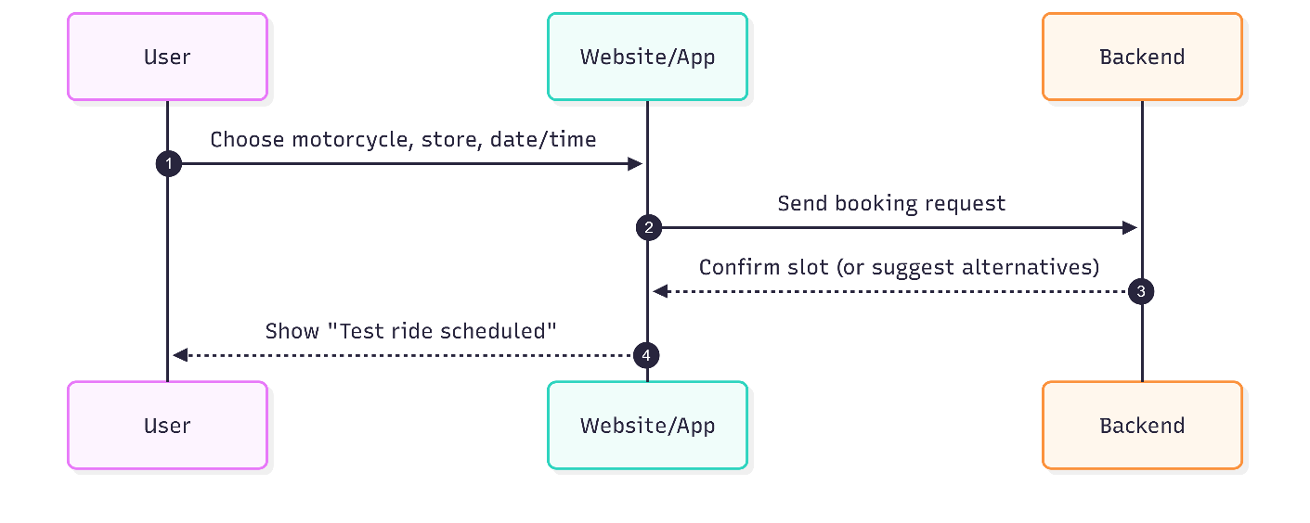
Figure 5: Book test ride sequence diagram
Description: This diagram presents the user-driven workflow for reserving a test ride. The user selects a motorcycle, preferred store, and a suitable time. The application forwards the request to the backend, which verifies slot availability and persists the booking. A confirmation is returned to the user to ensure clarity of outcome.
Key points:
- User initiates a structured request (motorcycle, store, time).
- System validates availability and creates a booking record.
- Immediate user feedback reduces uncertainty and improves experience.
- Interaction emphasizes convenience and self-service scheduling.
b. Purchase a Motorbike
  - 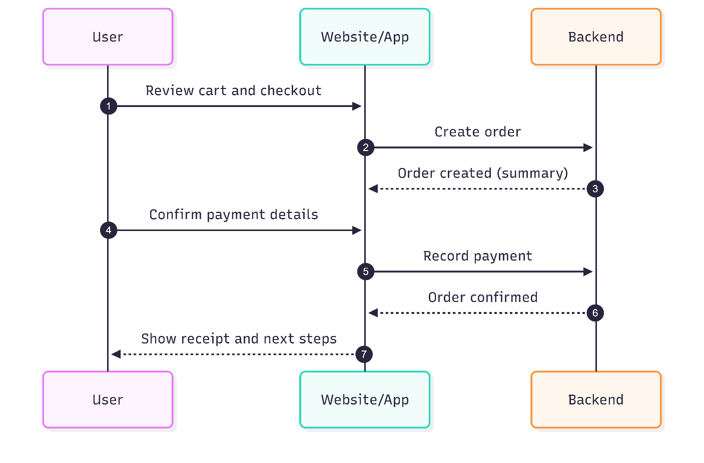
Figure 6: Purchase motorbike sequence diagram
Description: This diagram outlines the end-to-end purchasing flow from checkout to order confirmation. The user reviews the cart, confirms payment details, and the system creates the order and acknowledges payment. The application then presents a receipt and next steps to reinforce trust and transparency.
Key points:
- Clear progression: review → order → payment → confirmation.
- System records the order and acknowledges payment promptly.
- User receives a definitive receipt and post-purchase guidance.
- Interaction prioritizes simplicity, certainty, and user confidence.
c. Post in Forum
  - 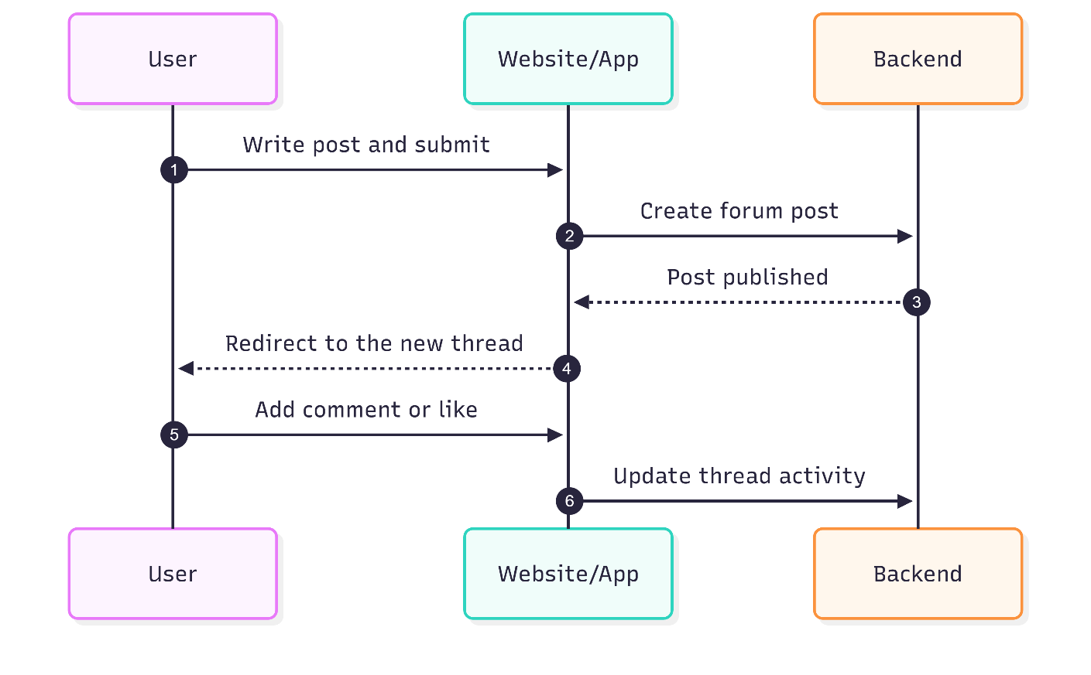
Figure 7: Post in forum sequence diagram
Description: This diagram describes the social interaction loop in which users publish posts and interact via comments and reactions. Upon submission, the system publishes the post, making it immediately visible. Subsequent engagement (comments, likes) updates the thread, sustaining community participation.
Key points:
- Low-friction publishing to encourage contribution.
- Immediate visibility strengthens community responsiveness.
- Thread activity (comments, likes) maintains engagement.
- Interaction focuses on openness, continuity, and user agency.
d. Admin Upload Motorcycle
  - 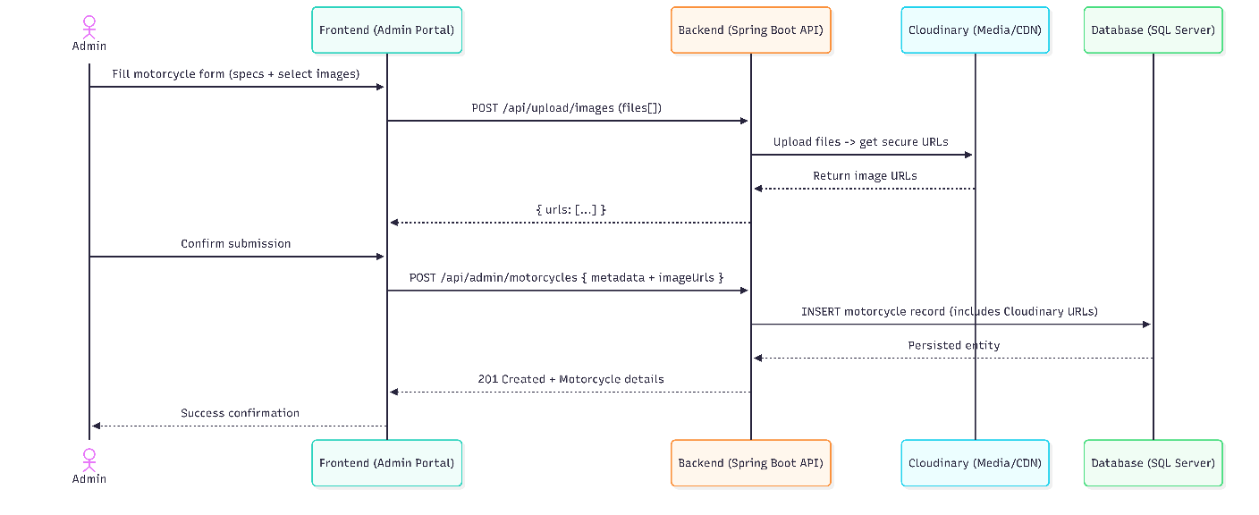
Figure 8: Admin upload motorcycle sequence diagran
Description: This diagram shows the administrative workflow for adding a new motorcycle to the catalog. The Admin enters specifications and selects images in the Admin Portal; images are uploaded to Cloudinary and returned as secure URLs; the Backend saves the listing with those image URLs in the SQL Server database; the item is immediately visible to users across catalog and search views, ensuring fresh and accurate inventory.
Key Points:
- Role-gated submission safeguards catalog integrity and prevents unauthorized changes.
- Two-step image handling (upload, then reference secure URLs) ensures reliable media delivery.
- Server-side validation of file type/size and required fields improves data quality.
- Cloud-hosted images via CDN provide fast rendering on user-facing pages.
- Immediate catalog surfacing supports discovery and market responsiveness.
- Status and stock captured on creation support downstream inventory operations.
4.3.2. Use case diagram
  - 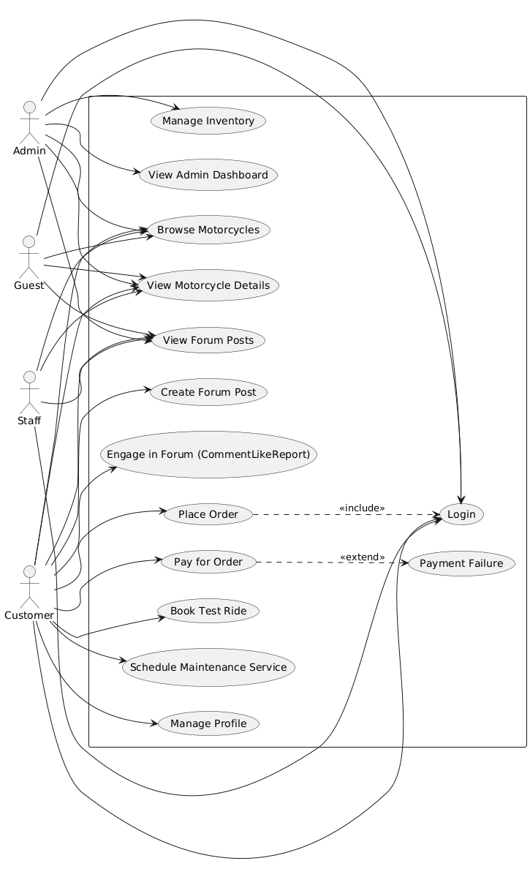
Figure 9: Usecase diagram
- Summary: The diagram models core user–system interactions across four roles (Guest, Customer, Staff, Admin) while highlighting one mandatory sub-process through include and one optional/alternative path through extend. Public discovery actions are shared by all roles; transactional and community actions require authentication.
- Include (UC_Order includes UC_Login): Checkout is a secured process that presupposes identity verification. By modeling “Place Order” as including “Login,” the diagram expresses that authentication is a mandatory prerequisite, ensuring account linkage, personalized fulfillment, and traceable transactions.
- Extend (UC_Pay extends UC_PaymentFailure): Payment may deviate into an exceptional pathway. The extend relationship captures this alternative course when authorization fails or a gateway error occurs. This preserves the base behavior (attempt to pay) while documenting the conditional branch that produces an error state and recovery options (retry or choose another method).
- Shared interactions: Browsing motorcycles, viewing details, and reading forum posts are public discovery use cases accessible to Guest, Customer, Staff, and Admin, emphasizing the platform’s openness and reducing friction in early exploration.
- Customer focus: Ordering, paying, booking test rides, scheduling services, managing profiles, and forum participation form the primary value path for end users. These use cases are intentionally minimal to communicate clear goals rather than technical procedures.
- Administrative stewardship: Inventory curation and dashboard oversight remain distinct administrative responsibilities, separated from public and customer flows to reflect governance, data quality, and operational visibility.
- Interpretation: Using include and extend clarifies process structure without overloading the diagram—include conveys a required step (security and identity), extend documents an exceptional variant (payment failure). Together, they provide a balanced view of normative and non-normative user journeys.
4.3.3. Class diagram
Figure 10: Class diagram
The domain model organizes users, inventory, transactions, bookings, services, and community content into cohesive classes with clear responsibilities.
Relationships reflect real-world ownership and collaboration (e.g., a user places orders; a motorcycle accumulates reviews and test rides).
Lifecycle states and audit timestamps are explicit, supporting operational reliability, analytics, and administrative control.
Entities
1.User
- Attributes: id, email, password (secure hash), firstname, lastname, phone, address, role (CUSTOMER/STAFF/ADMIN), isActive, created/updated timestamps.
- Purpose: Represents authenticated identities; owns personal data and activities (orders, bookings, services, reviews).
- Special: Role determines access; isActive supports account suspension/reactivation without data deletion.
2. Motorcycle
- Attributes: id, brand, model, year, category, price, status (e.g., AVAILABLE, OUT_OF_STOCK), description, engineType, displacement, power, torque, weight, topSpeed, fuelCapacity, stock, images, features, color, created/updated timestamps.
- Purpose: Core catalog item displayed to users, used in purchases and operational bookings.
- Special: Images and features are stored as simple value lists; stock and status change automatically in response to order lifecycle events.
3. Order
- Attributes: id, orderNumber (unique), user, motorcycles (list), totalAmount, taxAmount, shippingFee, discountAmount, paymentMethod, transactionId, status (e.g., PENDING, PAID, SHIPPED, DELIVERED), shippingAddress, notes, created timestamp, paid/shipped/delivered timestamps.
- Purpose: Transaction aggregate linking a user to one or more motorcycles with financial and fulfillment details.
- Special: Many-to-many association with motorcycles supports multi-item orders; status transitions update audit timestamps and drive inventory adjustments.
4. TestRide
- Attributes: id, user, motorcycle, store, scheduleDate and precise date-time, duration, location (derived from store), notes, status (e.g., PENDING, CONFIRMED), optional assigned staff.
- Purpose: Manages user bookings for trial rides at physical locations.
- Special: Supports staff assignment and time proposals; location is generated from store metadata for user-facing clarity.
5. MaintenanceService
- Attributes: id, user, motorcycle, serviceType, description, scheduleDate, status (e.g., SCHEDULED, COMPLETED), cost, bundleId, notes, technician (staff), created/completed timestamps.
- Purpose: Represents workshop appointments and service execution for customer motorcycles.
- Special: Technician linkage enables resource planning; completion sets an explicit timestamp for reporting.
6. Review
- Attributes: id, user, motorcycle, rating, content, approval flag, created timestamp.
- Purpose: Captures customer feedback and product evaluation.
- Special: Ratings are aggregated for display; an approval flag supports moderation before public visibility.
7. ForumPost
- Attributes: id, user, title, content, category, isHot, isHidden, likesCount, reportsCount, commentsCount, created/updated timestamps.
- Purpose: Enables community knowledge sharing and discussion.
- Special: Hot/Hidden flags support curation; counts are maintained to optimize list views and engagement metrics.
8. ForumComment
- Attributes: id, post, user, content, isHidden, created timestamp.
- Purpose: Threaded responses tied to a specific post.
- Special: Hidden flag facilitates moderation without removing historical context.
9. Store
- Attributes: id, name, address, phone, latitude, longitude, brand, licensed, contractStart, contractEnd.
- Purpose: Physical location for test rides and services.
- Special: Geospatial attributes enable nearest-store discovery; contract fields support administrative oversight.
10. Staff
- Attributes: id, name/contact, store assignment, role classification aligned with operational duties.
- Purpose: Operational personnel assigned to bookings and service tasks.
- Special: Store association anchors scheduling and availability checks.
11. ServiceOffering
- Attributes: id, name, subtitle, description, price, features, active flag, optional store association.
- Purpose: Configurable catalog for maintenance services presented to users.
- Special: Active flag toggles visibility; features list conveys value succinctly.
Relationships
- User owns many Orders, TestRides, MaintenanceServices, and Reviews (one-to-many).
- Order connects one User with many Motorcycles (many-to-many), modeling multi-item purchases without duplicating catalog entries.
- Motorcycle holds many Reviews and TestRides (one-to-many), enabling rich engagement and evaluation.
- ForumPost holds many ForumComments (one-to-many), forming coherent discussion threads.
- TestRide references one Store; MaintenanceService may reference one Staff technician; both reference one User and one Motorcycle.
Status and Lifecycle
- Orders progress through distinct states (e.g., PENDING → PAID → SHIPPED → DELIVERED) with timestamps recorded at each milestone for auditability and analytics.
- Motorcycles toggle status based on stock and transaction outcomes (e.g., OUT_OF_STOCK when stock reaches zero; reverts to AVAILABLE when replenished).
- Maintenance services and test rides use statuses (e.g., SCHEDULED, COMPLETED; PENDING, CONFIRMED) to coordinate operations and drive user notifications.
- Approval and visibility flags (e.g., review approval, post hidden/hot) support governance without erasing history.
Notable Design Choices
- Many-to-many Orders–Motorcycles: Enables flexible cart composition and accurate reuse of catalog entries.
- Denormalized counts and ratings: Maintained for high-performance listing and quick UI summaries without expensive live aggregations.
- Value lists for images and features: Lightweight representation avoids separate tables for simple attributes.
- Explicit timestamps: Provide clear audit trails and power dashboards without guesswork.
- Role and activity flags: Separate authorization (role) from account state (isActive) for practical administration.
Rationale
- The model balances clarity (well-defined ownership and lifecycles) with performance (pre-aggregated metrics, straightforward value lists) and governance (moderation flags, explicit statuses).
- It supports the platform’s three pillars: commerce (orders and inventory), operations (bookings and services), and community (posts and reviews), ensuring each area has the structure needed for reliable user experiences and effective administrative oversight.
4.4. Frontend and User Interface Design
4.4.1. Integration of Design Components
The design outcomes show that the three main platform functions—motorcycle trade, service scheduling, and community involvement—have been successfully integrated. The user interface prototypes demonstrate smooth transitions between various functional sections while preserving a consistent user experience and design language.
4.4.2. Scalability and Maintainability Considerations
Future scaling requirements are supported by the modular design approach, which is seen in the system architecture and interface components. A manageable implementation foundation is offered by the class diagram's distinct division of responsibilities and the use case requirements' precise definition.
4.4.3. Technology Stack Alignment
The chosen technological stack (React, Spring Boot, SQL Server, Cloudinary) is well-aligned with the design results. The class diagram layout supports the object-oriented methodology of Spring Boot and the relational data management features of SQL Server, while the component- based interface design aligns well with React's architecture.
4.4.4. User Experience Validation
By offering integrated functionality that removes the need for consumers to switch between platforms for trading, services, and community involvement, the thorough interface design fills the identified gap in the motorbike ecosystem.
4.5 Limitations and Future Considerations
Despite its robust architecture, the current deployment model exhibits specific limitations that outline considerations for future development.
- Scaling Constraints: The system currently operates on a single-node VPS architecture. While Docker Compose provides excellent container orchestration, it lacks the horizontal auto-scaling capabilities inherent in clustered orchestrators like Kubernetes.
- External Dependencies: The application's core responsiveness and functionality are heavily coupled to the uptime and latency of external third-party services (Google OAuth, Gemini API, VNPay, Cloudinary). Network degradation in these third-party APIs directly impacts the perceived performance of MotoMarket.
- Caching Deficiencies: The absence of a dedicated distributed in-memory caching layer (such as Redis) means that highly recurrent, non-transactional queries (e.g., fetching the public motorcycle catalog) consistently hit the SQL Server database. Under extreme concurrent load scenarios, this could introduce latency that a caching layer would otherwise absorb.
4.6. User Interface Implementation
The transition to Phase 3 necessitated a rigorous overhaul of the User Interface to elevate MotoMarket to a visually premium, commercial-grade platform.
1. Home Page Redesign and Dynamic Navigation:
The traditional static header was replaced with a dynamic hero banner featuring auto-sliding promotional carousels, utilizing high-resolution imagery sourced from Cloudinary. The navigation bar implements a sophisticated "Glassmorphism" effect (CSS backdrop-filter: blur()) that remains sticky during vertical scrolling, collapsing into a mobile-friendly hamburger drawer on smaller viewports.
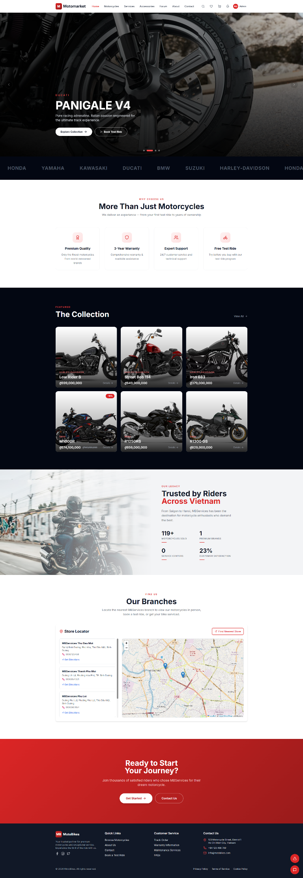
2. Accessories Marketplace Interface:
The UI constructs a highly responsive, multi-column CSS Grid layout for product cards. An interactive, sticky sidebar empowers users to filter inventory dynamically by Category, Brand, and Price. A slide-out mini-cart drawer executes a smooth translation animation when items are added, preserving the user's scroll position within the catalog.
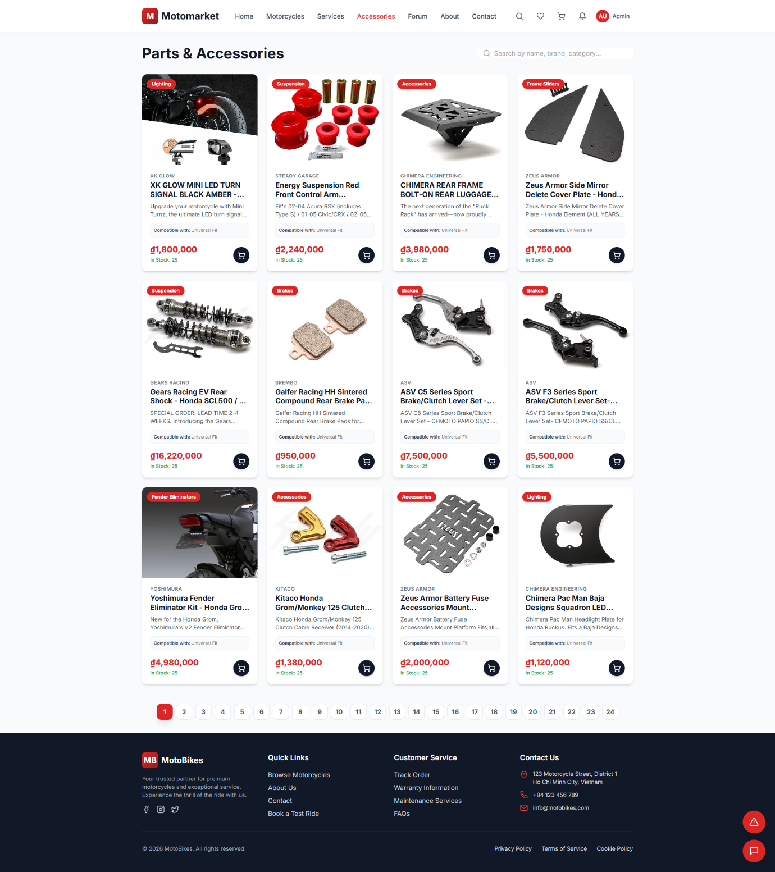
3. Interactive Store Locator (Google Maps):
The static list of branch locations was replaced by an embedded Google Map component. When the geolocation algorithm computes the "Nearest Store," the UI actively highlights that specific branch card and alters its map marker color to draw user focus, rendering a customized info-window with a prominent "Book Service Here" call-to-action.
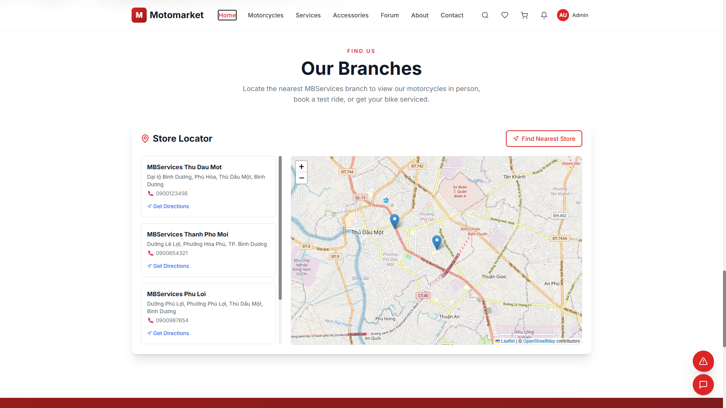
4. AI Chatbot Widget Interface:
The chatbot is rendered as a persistent, floating action button. Upon click, it expands via a CSS transition into a constrained chat interface utilizing clear color theory to delineate conversation flow. Crucially, a dynamic typing indicator (...) is rendered while awaiting the LLM's response, adhering to the principle of "Visibility of System Status" to manage network latency expectations.
5. Administrative Analytics Dashboard:
The administrative portal integrates advanced charting libraries to render complex data—monthly revenue streams, booking volumes, and user registrations—into interpretable graphs. A global "Branch Selector" triggers a reactive state cascade, instantly re-rendering all charts to display data exclusively isolated to that specific franchise location for precise operational oversight.
6. Secure Checkout and Payment Result Interface:
The checkout workflow features a multi-step accordion interface that systematically captures shipping demographics, license plate registration preferences, and payment methodology. Upon completion, a dedicated PaymentResult component intercepts the VNPay/MoMo callback parameters, rendering a dynamic cryptographic validation receipt indicating either successful ledger reconciliation or transaction failure.
7. Federated Identity and Profile Management Portal:
Authentication modals were redesigned to prominently feature Google OAuth integration. Crucially, a mandatory Complete Profile gated interface was engineered; if OAuth lacks necessary metadata (phone, address), the React Router traps the user in this specialized form to enforce data integrity before granting access to e-commerce features.
8. Community Forum and Post Detail Views:
To drive user engagement, the Forum UI implements a robust feed for discussion threads. Individual ForumPost views provide nested comment trees, utilizing optimistic UI updates to instantly render user interactions (likes, replies) before backend confirmation, maximizing perceived performance and community interaction.
9. Interactive Motorcycle Catalog and Details Page:
The primary motorcycle showroom features high-fidelity image galleries and detailed technical specification tables. The UI employs dynamic routing to fetch SEO-optimized product pages, rendering complex relational data (available colors, compatible accessories) into an easily digestible visual hierarchy.
10. Unified Shopping Cart and Wishlist Dashboard:
The Zustand state-managed Cart page aggregates heterogeneous items (Motorcycles and Accessories) into a cohesive ledger, dynamically calculating subtotal matrices and conditional shipping costs based on cart composition. A separate Wishlist UI provides persistent caching of desired items to preserve user intent across sessions.
11. Staff Operational Dashboard and Live Handoff UI:
Distinct from the analytical Admin portal, the Staff UI focuses on real-time execution. It features a WebSocket-powered (or SSE) notification panel for incoming AI chat escalations. Upon accepting a session, the UI transitions to a split-pane live chat interface, granting the staff member direct, low-latency communication capabilities with the customer.
12. Secure Registration and Authentication Forms:
The registration interface employs comprehensive client-side form validation with real-time regex checking for password strength (enforcing uppercase, lowercase, numbers, and special characters). The UI utilizes a split-screen design, combining the functional form with dynamic brand imagery, ensuring a frictionless onboarding experience while maintaining strict data hygiene before submission.
13. Password Recovery and Reset Interface:
The password reset flow encompasses two distinct interfaces: an initial request form and a subsequent confirmation page accessed via the email token. The confirmation interface visually renders real-time password strength indicators and matching validation, ensuring users meet cryptographic security policies when recovering access to their accounts.
14. Corporate About and Information Page:
The "About Us" page provides institutional context, integrating high-quality multimedia assets and typography to narrate the brand's history and operational mission. The layout utilizes structured CSS Grid sections to present core values, team structures, and corporate milestones, establishing trust and brand authority with prospective customers.
15. Administrative Accessories Management Interface:
Within the admin portal, the "Manage Accessories" module provides a comprehensive CRUD interface for auxiliary inventory. The UI implements advanced data-table architectures with client-side sorting, bulk selection, and pagination. Administrators can seamlessly upload media assets via Cloudinary, categorize items dynamically, and update stock thresholds through intuitive modal overlays, ensuring instant inventory synchronization across the e-commerce frontend.
16. Interactive Motorcycle Comparison Matrix:
A specialized comparison UI empowers users to juxtapose up to three motorcycles simultaneously. The interface employs a sticky header retaining the models' imagery while scrolling through a dense, tabular grid of technical specifications (engine capacity, ABS presence, fuel efficiency), facilitating data-driven purchasing decisions for customers evaluating complex product variations.
4.7. Deployment Architecture and Operational Discussion
The physical deployment of the application from a localized localhost developer environment to a publicly accessible, hardened production server represents the culmination of the software engineering lifecycle for this Capstone project. This section critically evaluates the deployment strategy, security posture, and performance characteristics of the production system.
4.7.1. Infrastructure Strategy and Container Orchestration
To guarantee environmental consistency and eliminate the classic "it works on my machine" deployment failure, the entire technology stack was containerized. The system is hosted on an AzVPS Virtual Private Server running Ubuntu Linux. A comprehensive docker-compose.yml configuration orchestrates the internal network topology.
- Networking isolation: The containers (Spring Boot backend, Python FastAPI chatbot, SQL Server database) operate on an isolated internal Docker bridge network. Only the NGINX proxy container exposes ports (80/443) to the host machine, completely shielding the database and backend services from direct public internet access.
- Service Dependencies: The orchestration file utilizes depends_on clauses and health checks to ensure the SQL Server container is fully initialized and accepting connections before the Spring Boot container attempts to execute JPA schema validations and data seeding.
- Frontend Delivery: The React frontend is processed via the Vite build tool (npm run build), generating a highly optimized, minified bundle of static HTML, CSS, and JavaScript files. Utilizing chunk-splitting, these assets are mounted directly into the NGINX container via Docker volumes for high-speed delivery.
4.7.2. Security Posture and Threat Mitigation
Security was a paramount architectural driver in Phase 3. The system employs defense-in-depth strategies across multiple layers:
- Transport Layer Security (TLS): The domain mbservices.io.vn utilizes Let's Encrypt certificates generated via Certbot. NGINX strictly enforces HTTPS, utilizing TLS 1.2/1.3 protocols. This encryption guarantees that all sensitive data—especially JWT session tokens, user passwords, and VNPay redirection parameters—is encrypted in transit, neutralizing packet-sniffing and Man-in-the-Middle (MITM) vulnerabilities.
- Authentication and Authorization: The purely stateless design of the JWT authentication mechanism proved highly resilient. The Spring Security filter chain intercepts all /api/* requests, cryptographically verifying the JWT signature using the backend's secret key before extracting the role claims (CUSTOMER, STAFF, ADMIN) to enforce endpoint-level authorization.
- Data Integrity and Cryptography: User passwords are salted and hashed using the BCrypt algorithm with a work factor of 10, protecting against rainbow table attacks. Financial integrity is guaranteed by the HMAC-SHA512 algorithm, which signs all outgoing VNPay payloads and validates all incoming IPN webhooks, mathematically preventing parameter tampering by malicious actors.
4.7.3. Performance Evaluation and Bottleneck Analysis
The production deployment validated several critical architectural decisions designed to maximize throughput and minimize latency:
- Asynchronous Execution: The decision to decouple transactional email dispatch using Spring Boot's @Async framework yielded significant performance dividends. Order confirmation emails are compiled and transmitted to Google's SMTP servers on a separate background thread, ensuring that the critical checkout UI thread returns a response to the user in under 100 milliseconds.
- Workload Isolation: The integration of the Google Gemini API successfully automated first-tier customer support. Crucially, by isolating this LLM inference logic into a separate Python FastAPI container, the system ensures that long-running external HTTP calls (Google API responses range from 1.5 to 4 seconds) do not consume and exhaust the finite thread pool of the primary Java Tomcat Servlet, thereby preserving core e-commerce performance during high-volume chat periods.
4.7.4. System Limitations
Despite its robust architecture, the current deployment model exhibits specific limitations that must be acknowledged. Firstly, the system operates on a single-node VPS architecture. While Docker Compose provides excellent container orchestration, it lacks the horizontal auto-scaling capabilities inherent in clustered orchestrators like Kubernetes. Secondly, the application's responsiveness is partially coupled to the availability of external third-party services (Google OAuth, Gemini API, VNPay, Cloudinary). Finally, the absence of a dedicated distributed in-memory caching layer (such as Redis) means that highly recurrent queries (e.g., fetching the motorcycle catalog) consistently hit the SQL Server database, which may introduce latency under extreme concurrent load scenarios.
Chapter 5. Conclusion and Future Works
5.1. Conclusion
The MotoMarket Capstone Project represents a comprehensive software engineering endeavor that successfully conceptualized, designed, and deployed a robust digital ecosystem. The fundamental objective was to resolve the severe fragmentation inherent in the modern motorcycle retail and after-sales service industry. Over the span of three rigorous developmental phases, the project evolved from theoretical domain models and static UI prototypes into a production-grade, highly integrated, and publicly accessible enterprise web platform.
Phase 1 established a firm academic and methodological foundation, mapping out complex, multi-actor workflows, identifying critical market gaps, and selecting a modern, scalable technology stack. Phase 2 validated this architectural hypothesis through the construction of a functional prototype, empirically proving that a layered, three-tier architecture—utilizing React, Spring Boot, and SQL Server—could efficiently orchestrate concurrent workflows across e-commerce, service scheduling, and community forum interactions.
Phase 3, the focal point of this final report, successfully bridged the gap between a functional prototype and a production-ready system by conquering the most complex operational and integration challenges:
- Financial Integration: By engineering a secure, cryptographically validated integration with the VNPay Gateway, MotoMarket transitioned into a fully functional commercial entity capable of handling secure monetary transactions and automated ledger reconciliation via IPN webhooks.
- Identity and Security: The implementation of Google OAuth 2.0 federated identity drastically reduced user onboarding friction while enforcing necessary data integrity via custom-built profile-setup routing gates. Furthermore, automated, asynchronous SMTP notification pipelines were established to guarantee secure password resets and order confirmations.
- Artificial Intelligence Integration: The introduction of the Gemini AI chatbot, backed by a dedicated, asynchronous Python microservice, demonstrated how modern Large Language Models can be seamlessly interwoven into traditional CRUD applications to intelligently automate customer support, while retaining a robust, real-time escalation pathway to human staff.
- Operational Readiness: Orchestrating the deployment via Docker containerization and securely serving the application through an NGINX reverse proxy with enforced TLS encryption on a live, registered domain (mbservices.io.vn) proved that the system architecture is resilient, scalable, and capable of operating securely over the public internet.
In conclusion, MotoMarket unequivocally fulfills its core mandate: it provides a centralized, highly integrated, and user-centric platform that drastically reduces the friction of motorcycle ownership, seamlessly unifying the disparate experiences of initial discovery, secure financial transaction, long-term maintenance scheduling, and rich community engagement into a single, cohesive digital environment.
  - .Future Work
While MotoMarket currently operates as a robust, feature-complete production platform, enterprise software development is inherently an iterative, continuous process. Several strategic areas have been identified for future enhancement to further scale the platform, optimize operational efficiency, and adapt to evolving market demands.
5.2.1. Expansion of Payment Ecosystems and Federated Identity
While VNPay serves as a highly capable primary payment processor in the domestic market, expanding the platform to integrate additional digital wallets (such as MoMo and ZaloPay) and direct Visa/Mastercard processing integrations will significantly increase checkout conversion rates by catering to a broader spectrum of consumer payment preferences. Furthermore, finalizing the rigorous business compliance checks required by Meta for Facebook OAuth integration will further broaden the platform's accessibility and streamline social onboarding.
5.2.2. Native Mobile Application Ecosystem
Currently, MotoMarket delivers a responsive web experience optimized for mobile browsers via Tailwind CSS breakpoints. However, to maximize user engagement and retention, the development of a native or cross-platform mobile application (utilizing frameworks such as React Native or Flutter) is a logical next step. A native application would empower the platform to leverage deeper hardware integrations, including utilizing the device's native GPS for highly accurate, background store routing, and implementing a robust Push Notification infrastructure (via Firebase Cloud Messaging) to replace email as the primary mechanism for real-time order updates, service reminders, and chat escalation alerts.
5.2.3. Architectural Evolution: Event-Driven Microservices
As user traffic scales and transactional volumes increase, the current monolithic structure of the Spring Boot backend may encounter vertical scaling limitations. Architecturally migrating heavily utilized, discrete domain boundaries—such as the Community Forum engagement engine and the AI Chatbot session management—into entirely independent microservices is recommended. By establishing an Event-Driven Architecture utilizing a distributed message broker (e.g., Apache Kafka or RabbitMQ) for inter-service communication, the system will achieve independent horizontal scalability, greater fault isolation, and the capacity to seamlessly implement real-time WebSocket broadcasting across the entire platform.
5.2.4. Advanced AI, Predictive Analytics, and CI/CD Automation
The current Administrative Dashboard excels at descriptive analytics (visualizing historical data). Future iterations must pivot toward predictive and prescriptive analytics. By harnessing the massive dataset of user search patterns, forum interactions, and maintenance frequencies, bespoke Machine Learning models could be trained and deployed. These models could offer hyper-personalized motorcycle and accessory recommendations to users, optimize branch inventory levels based on localized purchasing trends, or automatically generate highly targeted service reminders by predicting exactly when a specific user is due for an oil change. Finally, the implementation of a fully automated Continuous Integration/Continuous Deployment (CI/CD) pipeline using GitHub Actions would drastically reduce the operational overhead of deploying future updates to the AzVPS server, ensuring high software quality through automated unit testing and container registry pushes.

References

- Cycle Trader. (2022). Cycle Trader Overview. Trader Interactive. https://www.traderinteractive.com/cycle-trader/
- Cycle Trader Media Kit. (2024). Cycle Trader Audience Statistics. https://cycletradermediakit.com/
- Devitt Insurance. (2021). Top 10 Motorcycle Forums. https://www.devittinsurance.com/guides/top-10/top-10-motorcycle-forums/
- Feedspot. (2025). Top 40 Motorcycle Forums in 2025. https://forums.feedspot.com/motorcycle_forums/
- Powersports Business. (2024). Cycle Trader shares new and used motorcycle market insights. https://powersportsbusiness.com/top-stories/2024/07/03/
- cycle-trader-shares-new-and-used-motorcycle-market-insights/ The Admin Zone. (2022). Why are online motorcycle forums drying up and dying? https://www.theadminzone.com/threads/article-why-are-online-motorcycle-forums-drying-up-and-dying-imo-relevant-to-all-forums.154401/
- WorthEPenny. Check Cycle Trader Ratings & Customer Reviews. https://cycletrader.worthepenny.com/
- Zenith Motorcycles. (2024). Discover The Top 10 Motorcycle Forums And Connect With Motorcyclists Globally. https://zenithmotorcycles.co.uk/blog/10-best-motorcycle-forums/
- Baeldung. (2025). CRUD Application With React and Spring Boot. https://www.baeldung.com/spring-boot-react-crud
- BezKoder. (2023). Spring Boot + React + MySQL: CRUD example REST APIs. https://www.bezkoder.com/react-spring-boot-crud/
- Okta Developer. (2025). Use React and Spring Boot to Build a Simple CRUD App. https://developer.okta.com/blog/2022/06/17/simple-crud-react-and-spring-boot
- Medium – Vishal Dogra. (2024). Architecture Guide: Spring Boot, React, and PostgreSQL Full Stack application scalable to 100 million users. https://vishu221b.medium.com/architecture-guide-spring-boot-react-and-postgresql-full-stack-application-scalable-to-a-100-aba4a960df8f
- DHiWise. (2025). React Spring Boot: An Implementation Guide For Full-stack Devs. https://www.dhiwise.com/post/a-step-by-step-guide-to-implementing-react-spring-boot
- Medium – Bhargav Kanjarla. (2025). How To Combine a Java Spring Boot Back End with a ReactJS Front End App. https://medium.com/@bhargavkanjarla01/how-to-combine-a-java-spring-boot-back-end-with-a-reactjs-front-end-app-ed8d8ca65285
- Java Guides. (2023). Spring Boot + Microsoft SQL Server + JPA/Hibernate CRUD Restful API Tutorial. https://www.javaguides.net/2019/01/spring-boot-microsoft-sql-server-jpa-hibernate-crud-restful-api-tutorial.html
- Cloudinary. (2024). Integrate With E-commerce Platforms and CMS Early On. https://cloudinary.com/guides/e-commerce-platform/integrate-e-commerce-platforms-and-cms-early-on
- Cloudinary. (2024). Dynamic Media Platform: A Must-Have Technology for E-Commerce Stack. https://cloudinary.com/blog/why_dynamic_media_platform_is_must_have_for_ecommerce
- Cloudinary. (2024). Adopt the Best Media Capabilities for E-commerce. https://cloudinary.com/guides/e-commerce-platform/leverage-best-of-breed-media-capabilities
- Cloudinary. (2025). Choose the Right E-commerce Platform. https://cloudinary.com/guides/e-commerce-platform/select-the-right-e-commerce-platform-for-your-needs
- Cloudinary. (2025). Platform Overview. https://cloudinary.com/platform
- Cloudinary. (2023). Enhancing Composable Commerce: Cloudinary Integrates With commercetools. https://cloudinary.com/blog/enhancing-composable-commerce-cloudinary-now-integrates-with-commercetools
- Powersports Business. (2024). Study: consumer insights and brand preferences in motorcycle P&A. https://powersportsbusiness.com/features/2023/08/24/study-consumer-insights-and-brand-preferences-in-motorcycle-pa-purchases/
- Grand View Research. (2024). U.S. Motorcycle Market Size & Share | Industry Report, 2030. https://www.grandviewresearch.com/industry-analysis/us-motorcycle-market
- IBISWorld. (2024). Motorcycle, Bike & Parts Manufacturing in the US – Market Research Report. https://www.ibisworld.com/united-states/industry/motorcycle-bike-parts-manufacturing/856/
- Motorcycle & Powersports News. (2024). Q&A: Powersports Consumer Sentiment Forecast for 2024. https://www.motorcyclepowersportsnews.com/qampa-powersports-consumer-sentiment-forecast-2024/
- Motorcycle & Powersports News. (2024). The Future of Buying: Navigating Powersport Consumer Trends. https://www.motorcyclepowersportsnews.com/future-buying-navigating-powersport-consumer-trends/
- VNPay. (2024). Payment Gateway Integration Guide – Developer Documentation. https://sandbox.vnpayment.vn/apis/docs/thanh-toan-pay/
- Google Developers. (2024). Sign In with Google for Web – OAuth 2.0. https://developers.google.com/identity/gsi/web/guides/overview
- Google AI. (2025). Gemini API Documentation. https://ai.google.dev/api/rest
- Docker Inc. (2024). Docker Compose Overview. https://docs.docker.com/compose/
- NGINX. (2024). NGINX Reverse Proxy Configuration Guide. https://docs.nginx.com/nginx/admin-guide/web-server/reverse-proxy/
- Let's Encrypt / Certbot. (2024). Automated HTTPS Certificate Management. https://certbot.eff.org/docs/

